Binh Duong has surface water monitoring system automatically[1]
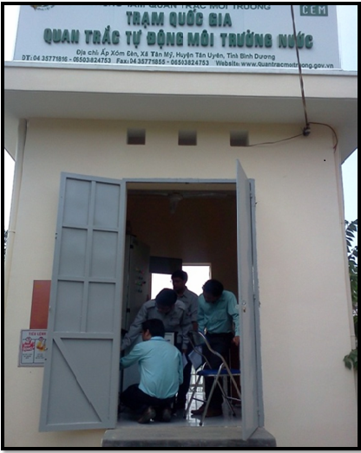
Surface water monitoring system automatically is a new step in technology to control water pollution that Binh Duong has decided to invest. Booting from May 3/2013, far investment project monitoring system automatically Binh Duong province's surface water has been officially put into operation. The project has been gradually contribute to changing the inspection, monitoring water sources, strict control of surface water quality in the Saigon River, Dong Nai and Thi Tinh
Staff of resources and environment monitoring centre inspection and supervision work station Vinh Nguyen (An Dien, TX.Ben Cat)

In the series of priority projects in the Environmental Protection Plan Binh Duong period 2011 - 2015, automatic monitoring system of surface water is an investment project is very urgent. According to Bui Duc Thuan engineer, Deputy Head of the scene monitoring, automatic Monitoring Center and Environmental Resources, the urgency here is that the project will not only contribute to improve qualifications and management capacities in the work environmental protection, but also for the purpose of building Binh Duong city where good living environment and gradually improve the quality of surface water and groundwater areas.
In addition to closely monitoring surface water in the area the first major rivers, the Department of Natural Resources and Environment also provides enhanced target device automatically monitoring water resources for regional surface water outfall and water supply watershed area for the water plant to serve the assessment, timely warning and accurately the changes in surface water quality; best service for water supply for production and daily life of the people. The time monitoring ground water quality automatic monitoring equipment are being made continuously in points Saigon River raw water pumping station in Thu Dau Mot (US District Ward, Thu Dau Mot City); Dong Nai River in Tan Hiep water pump station (throat catch Tan Hiep Water Plant), Uyen Hung Ward, Tan Uyen TX and Thi Tinh River in Vinh Nguyen Co. Ltd (An Dien, TX Ben Cat). This point is also the observation that 3 position monitoring network planning of environmental resources by 2020 Binh Duong province has approved.
Talking to our engineers Thuan said many issues raised to implement the project. And meaningful parameters parameters automatically monitoring surface water environment is very important. To synchronize with the network resources monitoring national surface water, the parameters were installed in the period 2013 - 2015 include: pH / with integrated temperature parameters, DO, salinity / with integrated parameters Ec and TDS, TSS / with integrated turbidity parameters, NO3. These parameters as required to meet the actual needs monitoring, allowing administrators to quickly grasp and timely than the surface water quality changes. And here is the open system should be able to extend other parameters for the next stage.
In addition, the stations are equipped with pumps and water from the river into the station, equipment closets, home storage station equipment water quality monitoring, communication devices - receive data via wireless GSM / GPRS; Direct lightning protection systems and Surge Protection; electrical systems ... For central operator stations, servers are equipped with data management software, control software, programmed to receive all the data from the monitoring base stations. The software system will provide measurement values at the stations according to data types: Number, graphs, alerts via email or text message, made report templates into the excel file. This system is open, scalable measurement parameters and expand the monitoring stations in the future.
With a budget of 7.778 billion investment, project systems of surface water monitoring stations have been automated to bring practical results. For the environment, this is an effective tool for the management and monitoring of water resources. For social service projects for forecasting, warning of pollution phenomena ... helps managers capture faster, more timely before the evolution of sudden change surface water, to put out the methods, solutions faster. Also, through the project, the surface water monitoring network in the province is an open system, constantly being added, upgrading and finishing, connect and share information seamlessly secured from the central local to the unified management of the Department of Natural Resources and Environment of Binh Duong.
As for the economy, which effectively gives the data on the environmental quality of surface water has always been updated, allowing managers to capture, evaluate the evolution of the environmental quality of surface water quick to make timely processing solutions, to minimize environmental pollution levels of surface water, creating economic value great environment, and contribute to ensuring water security of the Pacific in particular.
Automatic wastewater monitoring: Modern and environmentally friendly
Is home to many industrial parks (IPs), the environmental protection requires attention. Identify tasks, Binh Duong Industrial Zone is 100% established environmental profile, many industrial zones in operation has built wastewater treatment systems. However, to control effluent quality from the industrial zone is no simple matter.
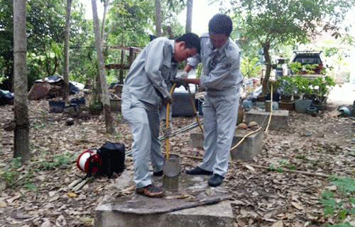

Personnel Monitoring and Environmental Resources Center to conduct surface water monitoring

[1]Bich Dao (2014), Binh Duong put the system of surface water monitoring stations in operation automatically, Revised at 08/02/2017, URL: http://stnmt.binhduong.gov.vn/3cms/binh-duong-da-co-he-thong-quan-trac-nuoc-mat-tu-dong.htm

